W368R-How to limit the computer in the LAN to access some websites by URL Filter?
Product line: Wireless Question category: Function configurations

Q：Why do we need to configure the URL Filtering?
A：In order to control the computer to access the websites, you can use URL Filtering to allow the computer to have access to certain websites at fixed time and forbid it having access to certain websites at fixed time.

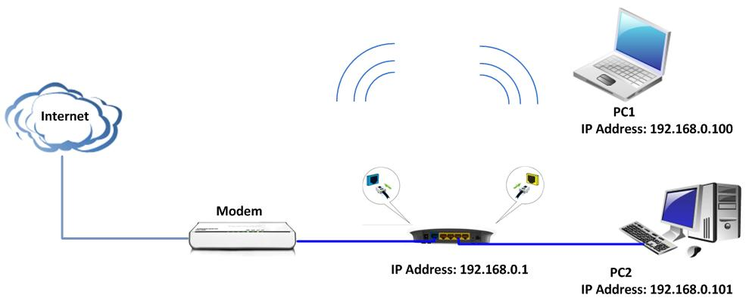

Steps are following:
1. Login the management page of the router.
2. Click the Security Settings→URL Filter Settings and you will find the page as below. There are two options (Disable, Forbid only). The URL filter is disabled default.

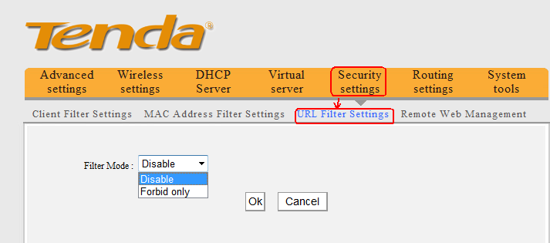

For example, you want to block the computers whose IP Address is 192.168.0.100 - 192.168.0.200 to access the websites that include “Google” from 8:00 am to 18:00 pm every day. And the computer with other IP Address can access the websites. You can set the router following the picture as below.

